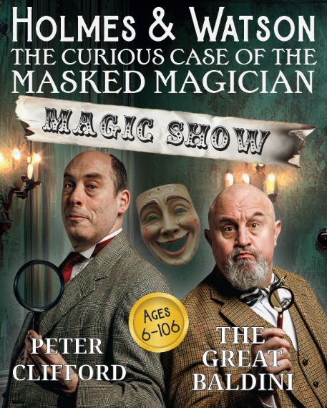

The Great Baldini and Peter Clifford present
HOLMES & WATSON
The Curious Case of The Masked Magician
A brand-new Holmes and Watson Magic Show!
When (in mid-show) the Masked Magician disappears, completely, magically and seemingly forever, Sherlock Holmes (with Watson in tow) plunges into a secret world of Edwardian Magic to solve the mystery of the missing Magi. A fresh Holmes and Watson adventure for all the family filled with Mayhem, Mirth, Mystery and…Magic.
From four of the most mischievously creative minds in the West Country comes a world first: a Holmes & Watson Magic Show! With stunning magic, a baffling mystery, beautiful sets, be prepared to be mystified when you see this sensational show on tour in 2026 and 2027.

The Fab Four Creators are:
- Peter Clifford (Holmes) is a Bristol-based actor, magician, writer and magical advisor for theatre and television. "One of my favourite magicians." Derren Brown
- Great Baldini (Watson) is a magical legend. Known the world over as ‘The Maharajah of Mystery’, he is a hugely entertaining stage and close-up magician.​ "Incredible!" Front Row, BBC Radio 4
- John Nicholson (Director) is an Olivier award nominated writer and director. "John Nicholson directs an evening of comedy gold." Reviews Hub
- Fi Russell (Designer) is a professional theatre designer of more than 100 shows for some of the most innovative theatre companies in the UK. “Fi Russell’s superbly simple but versatile set” British Theatre Guide
This wonderfully enjoyable show is suitable for all ages
Listings information
Venue: | INSERT VENUE
Dates: | INSERT DATE
Time: | INSERT TIME
Ticket prices: | INSERT TICKET PRICES
Box office: | INSERT BOX OFFICE NUMBER NUMBER
Website: | INSERT VENUE WEBSITE
For more information, photos, please visit the MASKED MAGICIAN Website
https://www.masquedmagician.com/

